Walk 8 Abbey Dore
Last walked in April 2019

Description. An 9 km (5.6 mile) walk across common land and fields. Many stiles.
Start. Dore Abbey, Explorer Map OL13 Grid 386303.
Directions from Tesco’s roundabout (Turn milometer to zero). Take the A465 to Abergavenny. At 6.9 miles TR sign posted ‘Abbey Dore 3’. At 9.1 miles at a road junction TL to Dore Abbey. Continue into Abbey Dore and at 9.8 miles, at a road junction you TL for Dore Abbey. At 10.2 miles, (150 metres past Dore Abbey) park on the L hand side of the road, in a lay-by oposite a pub called Neville Arms.

1. Abbey Dore. Abbey Dore is a village and parish in Herefordshire, the place is famous for its 12th century Cistercian Abbey, Dore Abbey. Dore Abbey was founded in 1147 by French Cistercian Monks who were not academic recluses but were skilled at managing their agricultural lands— in Dore’s case breeding sheep with fine wool. The Abbey was suppressed (dissolved) by Henry VIII in 1537 and the buildings sold to Lord John Scudamore who dismantled all the monastic buildings and sold the stone, all that remained (i.e. the present Abbey) was L as a roofless ruin until 1630. Restoring the ruins into a Parish Church was deemed an appropriate penance for John Scudamore’s great-great-grandson and the rebuilt church was re-consecrated in 1634. The Church you see today enjoys regular Church services, has a fine organ and is the venue for many concerts. From the lay-by you face the main road and TR to walk along the road towards the Abbey, after a few hundred metres on the R is the archway into Dore Abbey which was founded in 1147. TL and cross the road, go up a few steps to cross over a stile into a field F1. Climb up the steep hill to the top L hand corner to cross over another stile into F2. Cross the field diagonally, aiming for a white cottage. There is a stile beside the cottage but do not cross it, instead you continue up the field and go thru the gap into {F3}. Continue on up the L field edge, and near the top corner you TL to cross a stile and follow along an enclosed track. After a few metres the track bends to the R, and a bit further on it ends at another stile. Cross the stile onto Ewyas Harold Common. Bear R and continue uphill along a concrete path that gently ascends, you pass under power lines and continue along the path until it levels off and eventually brings you to the cattle grid leading off the common. Cross the cattle grid to join the tarmac lane and continue on the same line, passing farm buildings, (the first building on your L is called Meadow Croft). After about ¾ km you emerge onto a minor road. Continue in the same direction along this minor road for just over ½ km, and TR thru a metal gate into F4 (ignore the first metal gate you pass). There is a way mark sign post attached to this gate, which is about 400m past Cwm Hill Cottage (L). Bear L across the field and cross over a double stile into F5. TR and follow the hedge on your R, cutting off the field corner, to go thru a small metal gate into F6. Cross this field to cross over a double stile, and continue walking in the same direction to go into F7.

2. {F7}. Drop downhill; follow the power lines to cross over a stile into F8. Keep in the same direction as you continue down hill, bear slightly L, to cross over a ford at the bottom of the field. TR to follow the stream until a stile appears in the fence on your L. Cross the stile into F9 and walk up the hill to cross over a stile by Pen-Twyn Farm. Continue in the same direction to cross another stile a little way ahead, into F10. Go straight down this field to cross over another stile and down a short enclosed track into F11. Keeping the fence/tree line on your L, go down to the bottom of the hill and cross over a stile/wooden gate, then go over a stony track with a cattle grid on your L and continue in the same direction to cross over a wooden footbridge, up some steps and over a stile into a field with newly planted trees. Head diagonally L thru the trees to go thru a wooden gate and out onto the B4347 road.

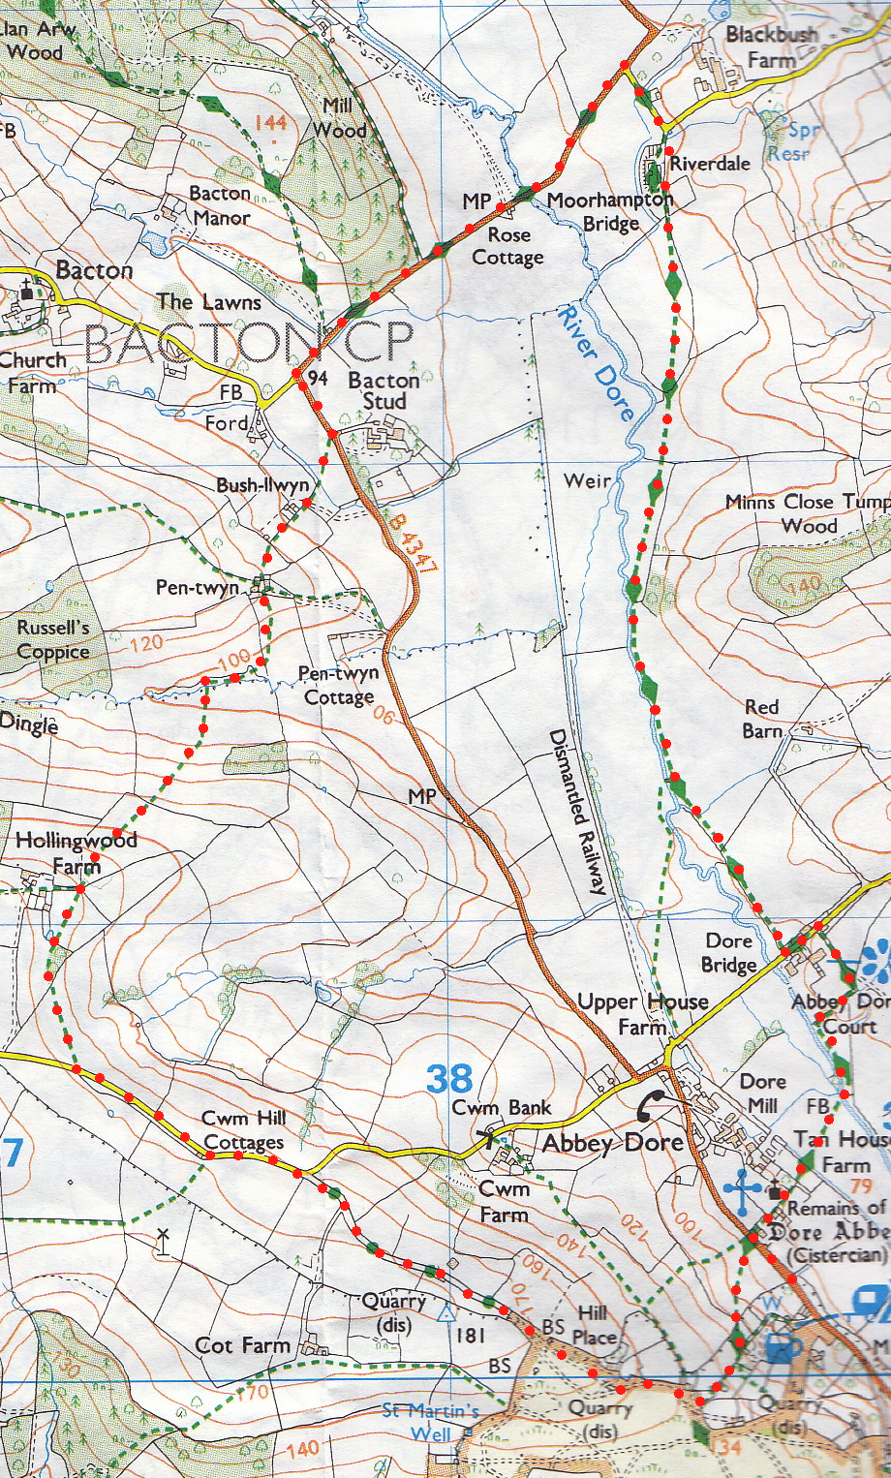
3. The B4347. TL, carry on along this road, which bends to the R going towards Hay, for about 1½ km. Turn into the next road on your R, sign posted Kerry’s Gate, and continue along this road until it turns sharp L. At this point you TR and continue straight on down the drive to a property called Riverdale, which was a Victorian workhouse. It is now private dwellings, so keep to the drive. An Act of Parliament of 1834 led to the building of workhouses such as that at Abbey Dore on the site that is now Riverdale. Instead of each parish being responsible for it’s own poor and needy, a system dating from the reign of Elizabeth I, parishes were to be grouped into Poor Law Unions, each run by a Board of Guardians and each bound to build a workhouse to serve the linked parishes. As workhouses went, the Dore one was small, built for eighty to a hundred people that might "farm out" their poor for a set sum, if they wished. At the end of the drive keep walking in the same direction to cross over a stile into an orchard. Go straight thru the orchard. Cross a double stile into F12. Continue in the same direction, (keeping the river on your R) to cross a stile into F13. Cross this field, aiming for bottom L corner, and go thru a small metal gate, then over a wooden footbridge and through another small metal gate into F14. TR, walk a few paces and TR to go thru a metal gate gap, then bear L and walk along an enclosed track, (the river is on your R). At the end of the enclosed track you go thru another metal gate and back into F14. Walk a few paces and go thru another metal gate and continue along an enclosed track. At the end of the enclosed track go thru another metal gate into a field, and continue along the R field boundary, a fence and the river is on your R. You then go thru a kissing gate and along an enclosed track to go thru a small wooden gate and then a kissing gate and onto a main road, with Abbey Dore Court on the opposite side.
4
3
2

4. Abbey Dore Court. TL, 100 metres along the road you TR and walk along a footpath, the large building on the corner is the old Magistrates Court. Follow the footpath to a kissing gate to the R of some large metal gates and continue round to the R, to rejoin the River Dore. Follow the river to reach a concrete gated footbridge, and cross over the river into F15. Head for the L side of the Abbey as you cross this field. Cross a small wooden footbridge then go thru a kissing gate. Walk towards the abbey; go thru another couple of kissing gates to enter the grounds of Dore Abbey. Continue in the same direction to leave the Abbey along the main path onto the main road, TL and return to the start.
1

